GCU E-Week 2020 Design Competition Rules – Intermediate Bracket
Final Bridge Design Test
- Teams may run as many tests as they desire before their final design test.
- Teams must test their final bridge design the week of E-Week, (February 14th-21st).
- Teams are expected to abide by the following guidelines:
  - The build of the test must be recorded in time-lapse fashion, and must be provided via email to the GCU representatives listed below.
  - Teams must be available to have their local GCU counselor present for the final bridge test in order to ensure fairness within the competition.
    - Time-lapse videos must consist of the following standards:
      - A time-lapse video must be uploaded to YouTube, set on ‘Public Status,’ and sent to the GCU representatives listed below.
      - Must show the full building of the bridge, from start to finish.
      - If the local GCU Counselor is unavailable to be present for your team’s final design test, teams must submit a final test video. This video must show the full amount of weight placed on the bridge. Once it breaks the bridge, in a continuous shot, teams must weigh the weight applied to the bridge, and have the final measurement visible on camera. Along with the time-lapse video, this video must be uploaded to YouTube, on ‘Public Status,’ and sent to the representatives below.
    - Videos, in a YouTube link format, must be sent to the following emails:
      - Your team’s local GCU Counselor
      - Tyler.lago@gcu.edu
      - Alex.garwood@gcu.edu
      - Daniel.armas@gcu.edu
  - Teams must also post their team’s video on their social media platform, using the following hashtag: #GCUEWeek2020
    - This must be included in the title of the team’s video
  - Teams must submit their final test prior to 12:00 PM (Arizona Time) on Friday, February 21st. All late submissions will not be considered in the final results.
How GCU Will Announce the Winning Team
- Grand Canyon University will do the following to notify teams when announcing the final results on the afternoon of Friday, February 21st:
  - The winning team will be sent a confirmation email informing them of their team’s success, as well as the prize they will receive.
  - All losing teams will be sent a confirmation email stating that unfortunately their team did not win.
  - The winning team’s video will be re-posted on GCU’s social media platforms via the YouTube video link provided.
Design Specifications
- Teams may only utilize the following materials from the following vendors:
  - 4oz of Wood Glue Bottle (Max) – Link to the vendor
  - 1000 Toothpicks (Max) – Link to the vendor
- Teams must test the final bridge design by wrapping at the bottom of their bridge, and using a hook, attach the weight to the rope. The photo below is an example:
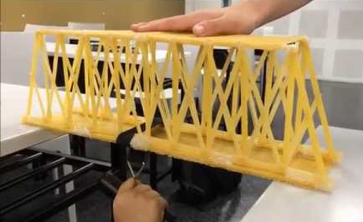
- This competition will be measuring the maximum weight in Newtons. The ratio between max load vs weight will not be considered in this competition.
- Maximum dimensions
  - Length of the span of the bridge (the gap between the cliffs): 3 ft.
  - Height: 2 ft.
  - Width of the surface of the span: 8 inches (minimum 2 inches)

